SAVEETHA SCHOOL OF ENGINEERING
CSA15- CLOUD COMPUTING AND BIG DATA ANALYTICS
LIST OF EXPERIMENT 5
5) Create a simple cloud software application for Library book reservation system for SIMATS library using any Cloud Service Provider to demonstrate SaaS.
SOL
AIM:
To design and implement a simple cloud-based Library Book Reservation System customized for the SIMATS library using Zoho Creator and deploy it as a Software as a Service (SaaS) application, demonstrating relational table mapping via lookup links, student role handling, and inventory tracking over the internet via a web browser.
PROCEDURE:
- Sign In: Sign in to the Zoho Creator cloud platform using the registered student account credentials.
- Application Shell: Create a completely fresh standalone application by selecting the Create from Scratch option and name it SaaS Experiment 5 SIMATS Library.
- Form 1 (Books Table): Design the first data entry form named Books, adding three Single Line text fields labeled Book Title, Author, and ISBN Number. Publish and save the form structure.
- Form 2 (Students Table): Design the second data entry form named Students to manage member data, adding a Name field labeled Student Name and a Single Line text field labeled Register Number. Save the form configuration.
- Form 3 (Library Reservations Relational Table): Create the third form named Library Reservations to act as the relational junction mechanism connecting students to issued literature:
  - Drag a Lookup Field linking directly to the Students form, choosing Student Name as the primary display index.
  - Drag a second Lookup Field linking directly to the Books form, choosing Book Title as the primary display index.
  - Add a Date field labeled Reservation Date to track library booking timelines.
- Report Generation: Automatically generate independent list view reports for Books, Students, and Library Reservations to facilitate multi-tenant search filtering, data browsing, and immediate ledger sorting via the cloud environment.
- Deployment & SaaS Access: Click on the blue Access This Application button to securely host and deploy the automated library tracking system live onto the Zoho cloud platform.
- Functional Cloud Testing: Verify live structural dependencies by sequentially inserting 3 unique sample entries into the Books form, 3 entries into the Students form, and completing cross-table operational lookup mappings inside the dynamic Library Reservations window.
SNAPSHOTS:
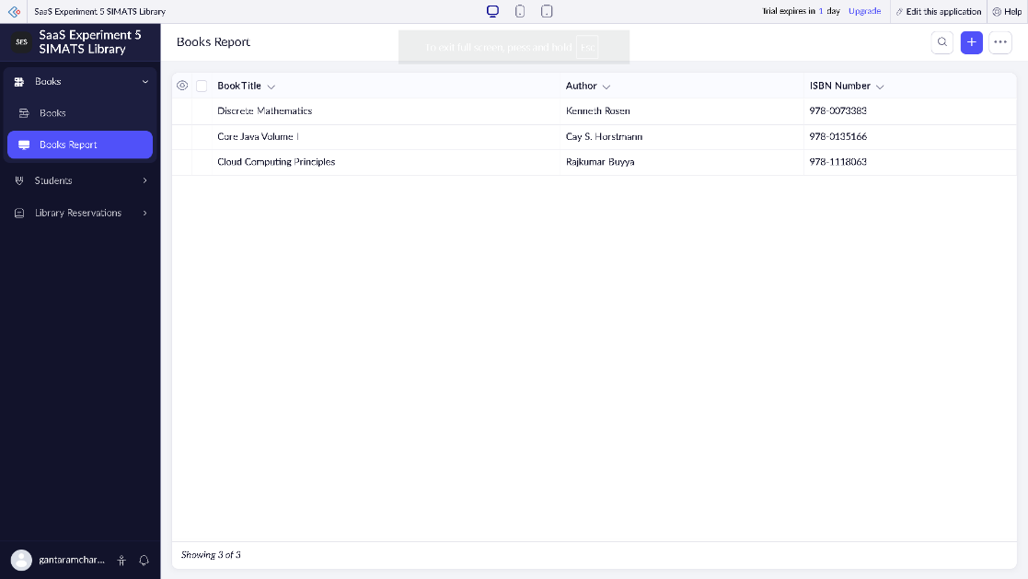

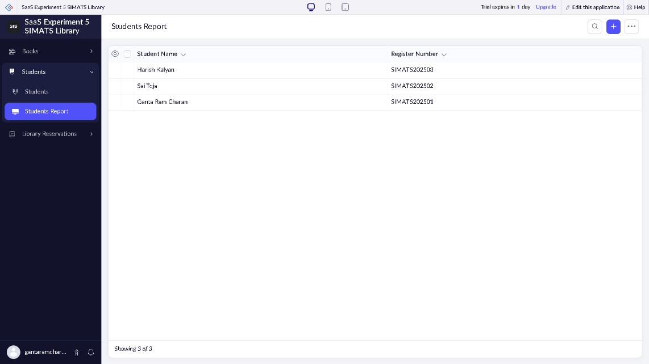

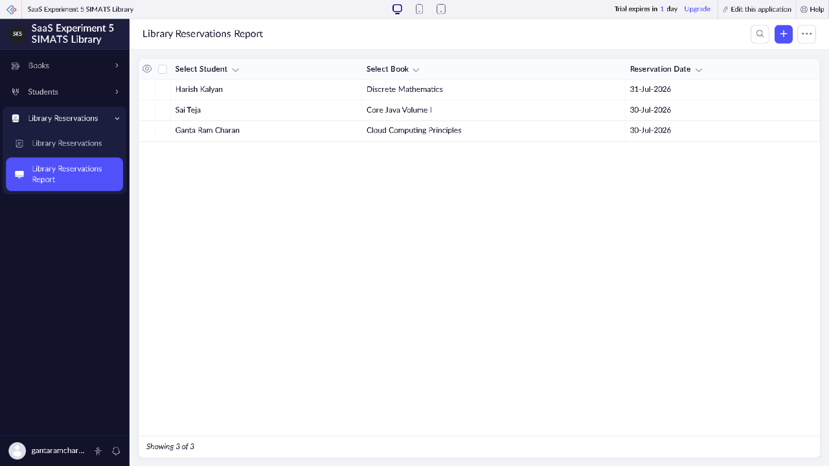
RESULT:
A relational cloud-based Library Book Reservation System application for the SIMATS library was successfully developed, integrated, and deployed using the Zoho Creator SaaS framework. The architecture enabled robust cross-form lookup connections and immediate multi-user accessibility directly via an internet web browser without local server deployment, successfully fulfilling Software as a Service (SaaS) criterion.

